TWIST-R-LOCK
Rapid insert suction cup retainer system
Twist-R-Lock Hard Retainers
Metal Detectable Part # TRL 1005H (122FH)

TWIST-R-LOCK Standard Retainers
Metal Detectable Part # TRL 1005 (122F)

Fits most standard cups used in Bakery Depanner applications

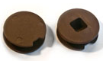
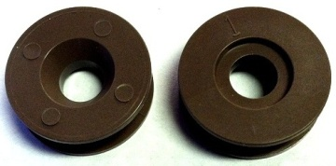
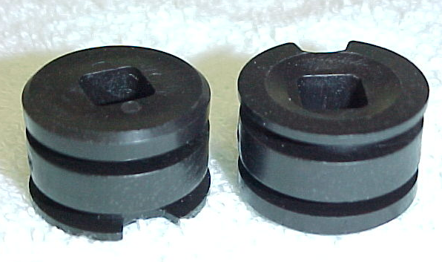
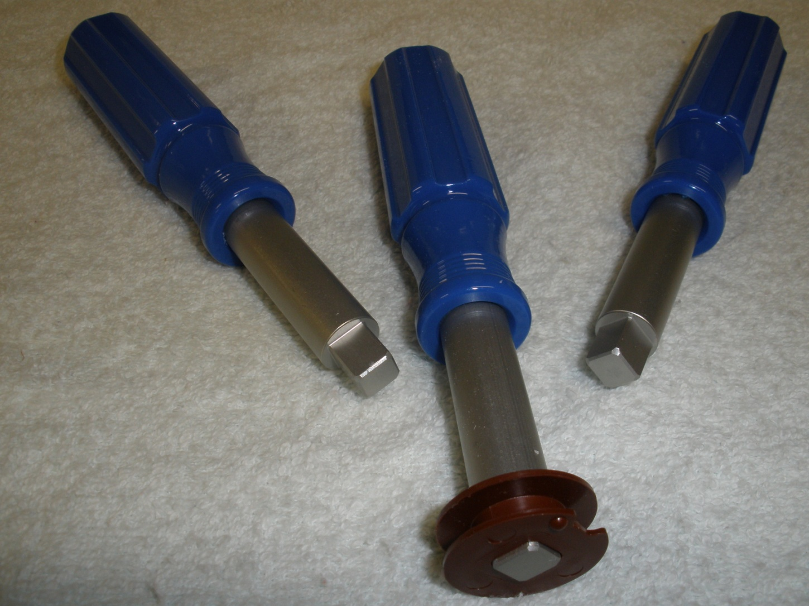
Twist-R-Lock Round Hole Retainers
3/8" diameter round Part # TRL 1008 (122RH3)
5/16" diameter round Part # TRL 1009 (122RH5)

Twist-R-Lock Plugs TRL-122FP
Standard or Hard
Rubber Washers TRL-122W
Insertion Tool
Part # TRL 1001 (122T)

Twist-R-Lock Tall Retainers
Metal Detectable Part # TRL 1005T (122FL)

C. M. Products Company
P.O. Box 3069 St. Peters, MO 63376 USA
Voice (636) 928-8345 FAX (636) 447-2305
www.cmproductscompany.com

TWIST-R-LOCK products are designed to fit existing Depanner Equipment in the use in modern production facilities. The unique leading edge design of our retainer makes installation into cups and belts as easy as turning a screw.
Premium Grade Silicone Rubber is used for temperature applications of 400° F.
Intermittent Higher temperature exposure may reduce cup life.

Dist. By

