Standard Duty Heatwand
With Teflon coated tip 5.16

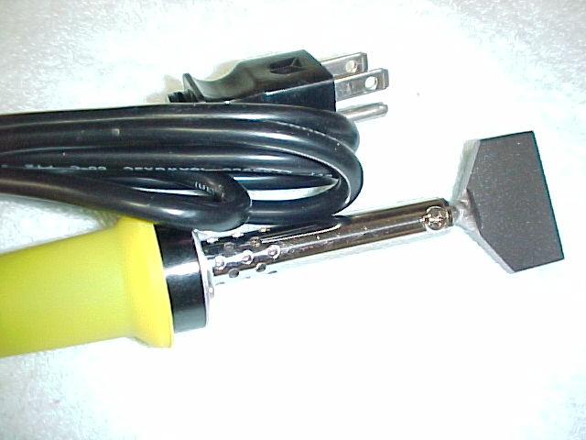

Wand includes tip # SDTIPA (as shown) or SDTIPB Please specify 120V or 240V when ordering
Part # BB-2145A (120V)

- For use with most thermoplastic profile belting
- Two wand tip styles for most belt applications
- Safety wand stand included
- 120V or 240V with molded ground plug

Distributed By:

