Baader Fish Filleting Machinery Replacement Spike Belts

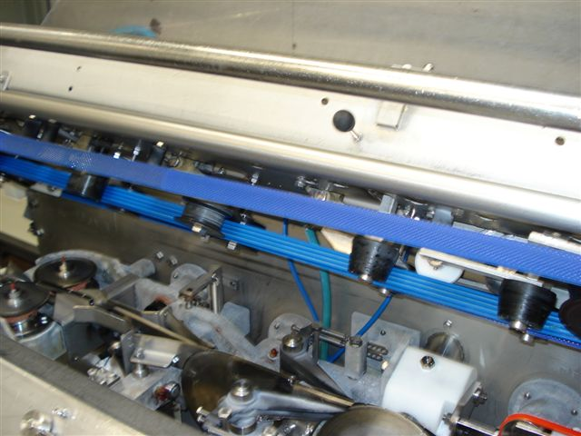
2820mm L x 26mm W x 13mm OAG

Endless Construction or Open End

Used on the following Machines:

- 34/234
- 35/235
- 36
- 39
- 134
- 135
- 221
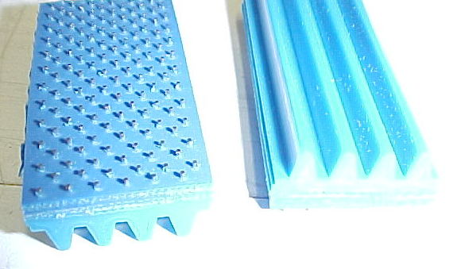

OEM Replacement Quality

Blue Gripper Belt Base Stainless Steel Gripper Spikes

