
TRIAC-ST

Hot air blowers for many industrial applications 2.2015
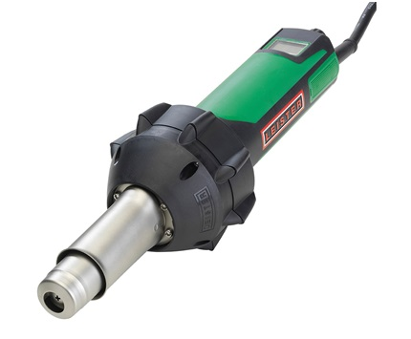

Complete with HD Pencil Tip for use with Speed Nozzles

- Automatically switches off when carbon brushes reach their minimum to avoid armature damage
- Temperature is electronically controlled, independent of voltage and ambient temperature fluctuations (PID control)
- 110V service with polarized plug
- Reduced danger of getting burned due to the new adapter tube with heat protection
- Complete range of push-fit nozzles for round and profiled welding as well as cleats and guides
- Easy welding thanks to the light weight and small diameter handle
- Includes Pencil Tip adaptor nozzle

Available Tips and Nozzles:
- 7 or 9 mm welding rod Speed Nozzle each
- HD K-10 (O section) guide installation nozzle
- HD K-13 (A section) guide installation nozzle
- HD K-17 (B section) guide installation nozzle

Dist by:

