Cut Rite
For square cutting of profiles and narrow width belting

Part # BB-181

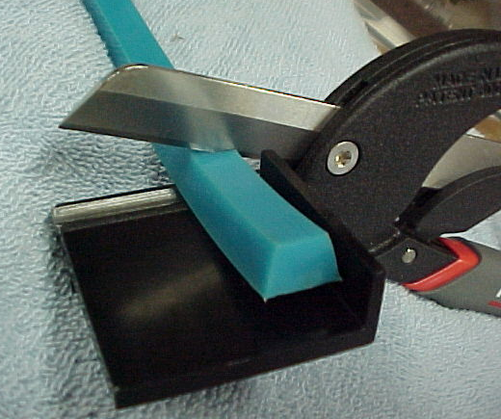

- 2” Belt platform with safety stop
- Heavy Duty cutting blade and anvil
- Even pressure for clean square cuts

C. M. Products Company
P.O. Box 3069 St. Peters, MO 63376 USA
Voice (636) 928-8345 FAX (636) 447-2305
www.cmproductscompany.com

Distributed By:

