Depanner Cups
Premium Quality Silicone Rubber

Ring Top Cups
Metal Detectable
Product
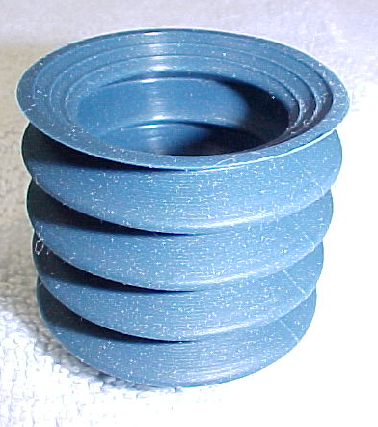
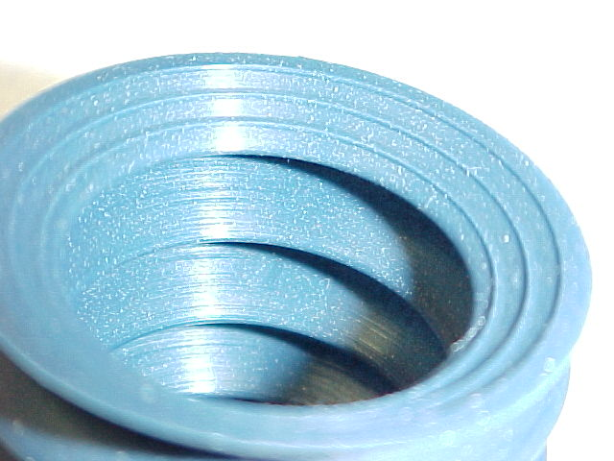

The highest quality Silicone Rubber is precision molded into Depanner cups with concentric rings at the pick-up zone.
This helps to prevent seeds and special toppings from leaking vacuum at contact points. Two styles to choose from:
121B Metal Detectable BLUE 45 Duro 121C Hi-Temperature Clear 40 duro

RING TOP CUP
Part # TRL-121B
Part # TRL-121C

39 mm
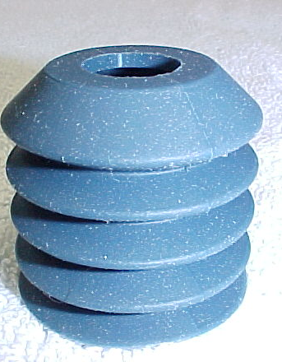
14 mm

37 mm

Dist. By

