SOFT LIP Depanner Cups
Extra-Soft 30 Durometer Silicone Rubber with extra thin lip
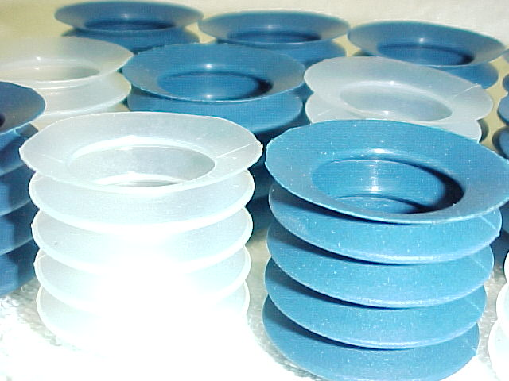

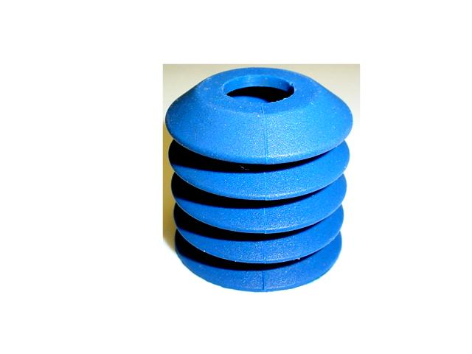
The highest quality Super Soft Silicone Rubber is precision molded into Depanner cups with extra thin lip area for a softer pick-up zone. Two styles to choose from, Clear and Metal Detectable Blue. Fits most standard retainers.

Metal Detectable
Product
42 mm
15 mm

15 mm

Taper TOP Soft Lip
Part # TRL-120C
30 Durometer
TAPER TOP Metal Detectable
Part # TRL-120B
30 Durometer
42 mm

38 mm

38 mm

Dist. By

