Depanner Cups
Extra-Soft 30 Durometer Silicone Rubber Pizza cups

\ 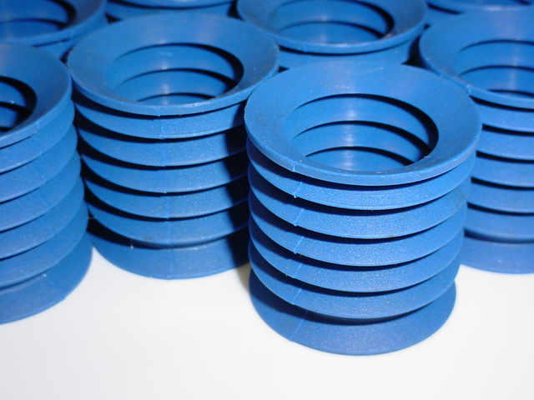
Metal Detectable
Product
The highest quality Virgin Silicone Rubber is precision molded into an extra- soft, flexible, extremely durable depanner cup.

Fits most standard retainers sold today.

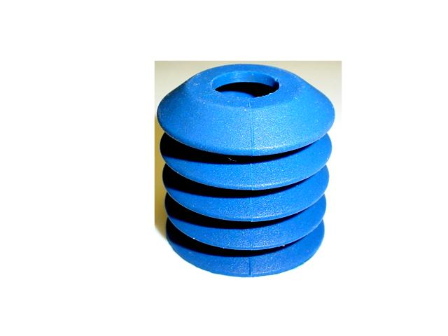
TAPER TOP
Part # TRL-119B
14 mm

35 mm
33 mm

Dist. By

