Depanner Cups

Soft 40 Durometer Silicone Rubber

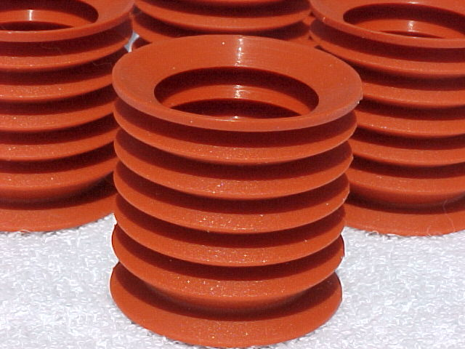
Metal Detectable
Product
The highest quality Metal Detectable Silicone Rubber is precision molded into a soft, flexible, extremely durable depanner cup. Two styles to choose from.

Fits most standard retainers sold today.

16 mm

42 mm
40 mm

15 mm

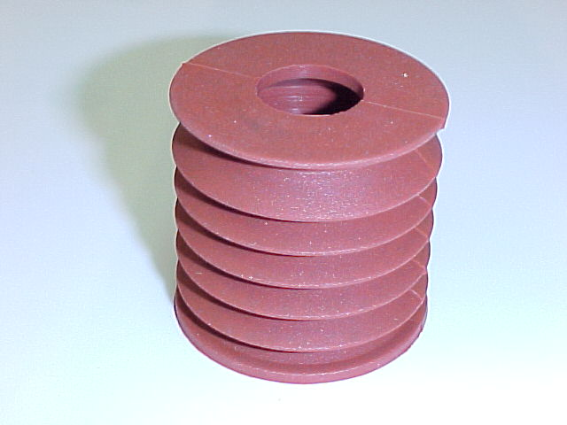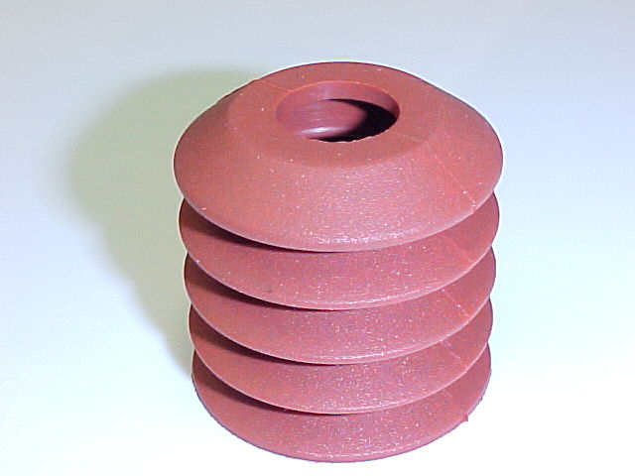
41 mm

38 mm

TAPER TOP Metal Detectable
Part # TRL-118A
FLAT TOP Metal Detectable
Part # TRL-117A

Dist. By

