BLACK-MAX 2.15
Joins 1/8” - 5/8” Round & Vee type thermoplastic belts

STANDARD DUTY COMPLETE KIT

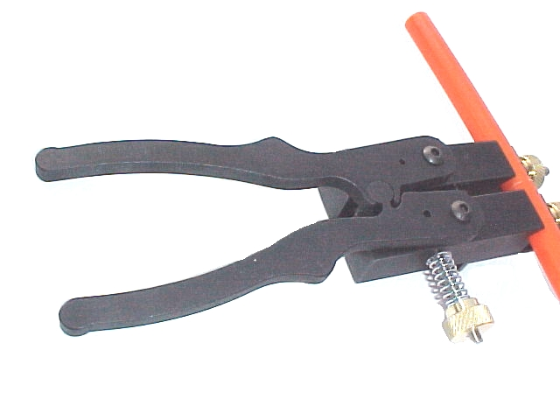

Aluminum Fixture

BB-2103
with handle kit installed

Now Available in 220V

Flush Cut

Trimming Tool

BB-170

40 Watt Heatwand & Safety Stand with TFE coated blade
BB-2145

with SDTIP A

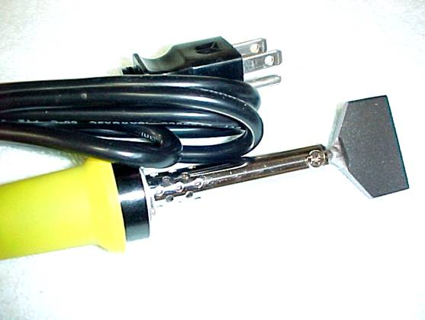

Flush Cut

Trimming Tool

BB-170

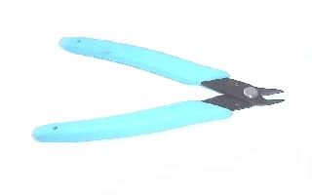

- Welds most Polyurethane/Polyester profile belting
- Industrial Duty 40 watt Heatwand w/TFE Tip & stand
- Auto-Spacer belt end locating device
- Flush cut trimming clipper included
- Completely assembled-ready to weld

Distributed By:

