AP-1400 Belt Bonder
Full feature automatic heat press
Operational guide

- Always use correct power source for your AP-1400. Whenever possible, plug unit directly into receptacle, avoiding extension cords which can cause power drops.
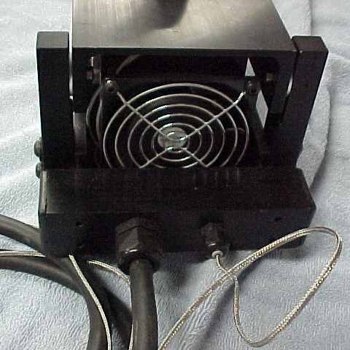

- Keep fan clear of obstructions to allow free air flow. Blockage of air flow will result in uneven cooling and imperfect splices.

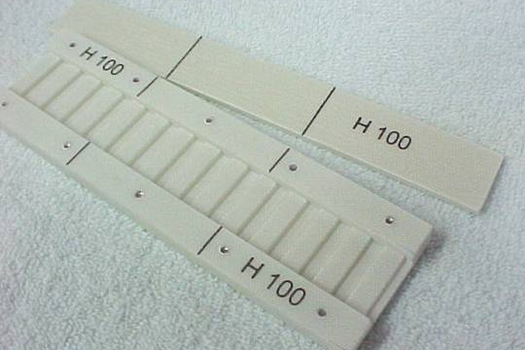
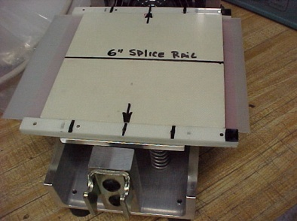
- The AP-1400 heat press is designed to be used with a splice rail made specifically for the belt type you are using. These rails allow for your belt type to be held in the correct position for proper cook cycles.

- Always load the splice rail into the center area of the heated plattens. This will distribute the spring pressure evenly when the AP-1400 is closed. Increased compression can be applied to spring closure, by adjusting the hinge leg attachment screws, and threaded ends of U clamp assembly. When closed and latched, the containment screw projection should be of equal length. Platens are uniformly heated top and bottom for proper melt flow of most belting types. Note: AP-600 pictured below for reference only.

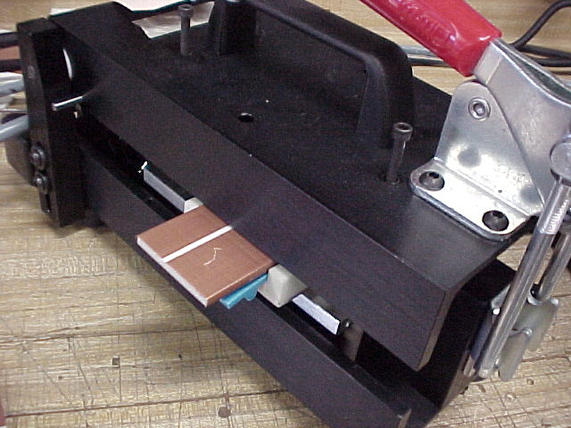
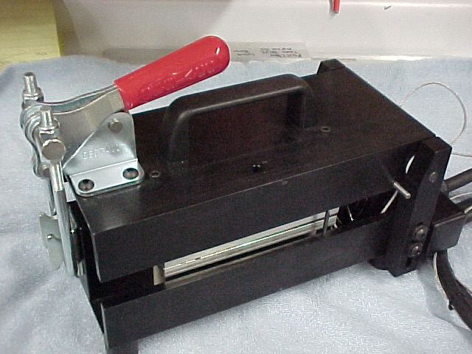

Same in 4 places

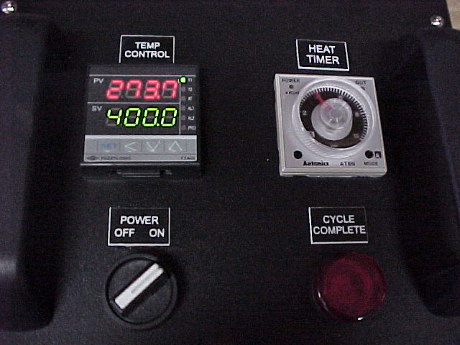
- Your AP-1400 is equipped with a “set and forget” control box. The external control modules allow you to select specific heat temperatures for the heated top and bottom platens. You may also adjust the soak time or heat time. Once these values are determined and set, the control box will operate to these settings without further attention. The AP-1400 control box is pre-set at the factory to a 30 minute cool down cycle. The timer controls are located inside of the box.

- Do not interrupt the cooking cycle, once the control box has been turned on. If you need to stop the cycle, turn the control box to the power off which will reset the digital controller. This will then start the entire cycle again

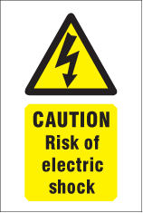
- Do not use the AP-1400 heat press where it can be exposed to water or wet conditions. This could cause damage to the control box and pose a health hazard to the operator.

- This unit is equipped with an internal line fuse which will protect your unit against electrical overload and dead short situations. If the unit completely losses power when the device is energized, and you have exhausted all other possibilities, check this internal fuse for integrity.
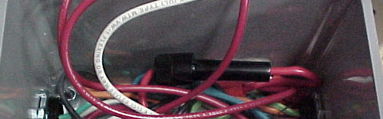
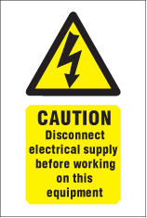

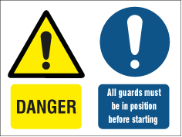
This condition normally indicates a major electrical problem with this unit. Care should be taken to locate and correct the cause of the malfunction before resuming the use of this device.

- When working on this control box, always remove power cord from power source.

