MAXI-TIP LONG LIFE SCRAPER BLADES 2019
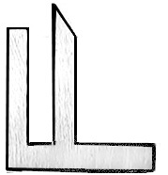
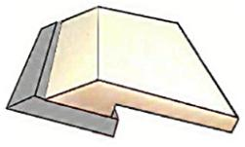
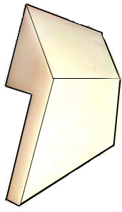
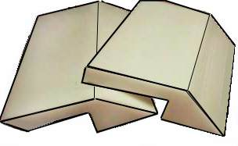
Dual Durometers
MAXI-TIP 2 & 3
BLADE HOLDER
MAXI-TIP 1

MAXI-TIP 1 (MT-1) is manufactured from a premium compound of abrasion resistant TPU resins, which have been specially selected for stability and toughness. The flexing action of the MAXI-TIP provides SUPERIOR cleaning and plowing performance, allowing belt lacing, and joints to pass under the scraper. This substantially increases both belt and lace life! This unit is recommended for trough angles, V-plows and "arc" mounts. White in color.

MAXI-TIP 2 (MT-2) is manufactured for applications where more rigidity and stiffness are required. This specially blended UHMW polymer is manufactured for its low friction and release properties. MAXI-TIP 2 can be used for pulley cleaning, heavy product plowing and general-purpose applications. White in color.

MAXI-TIP 3 (MT-3) is manufactured from the same specially blended UHMW polymer as Maxi-Tip 2, but in a larger more robust profile for heavier duty applications. White in color.

Blade Holder (MTBH) is a 6005-T6 hardened aluminum extrusion, finished in clear anodize. This rigid holder allows Maxi-Tip 1 & 2 belt scrapers to be properly presented to the work area, and maintain a constant, even pressure over their entire working length. These holders help to keep your conveyors clean, neat, and sanitary. These Blade Holders allows easy installation of replacement of scrapers.

MAXI-TIP Dual Durometer (MTDD) has a co-extruded rigid PVC base for mounting, and an 95A TPU flexible tip - all in one piece! The larger base allows for direct mounting to cross supports and frames, where a blade holder cannot be installed. White in color.

MAXI-TIP Dual Durometer-T (MTDD-T) scraper has a co-extruded 95A Urethane base for mounting, and an 75A flexible tip. The larger base allows for direct mounting to cross supports and frames. Same physical size as MTDD. Tan in color.

Dual Durometer Scraper -10 (DDS-10) is a cast urethane version in 10 ft. lengths. Same physical size as MTDD. Tan in color.
All Maxi-tip Plastic Scrapers are manufactured from FDA approved compounds.
Maximum operating temperature on all scrapers is 180°F / 83° C

MT-1 | 7.5 ft. section | $ 105.00 each
MT-2 | 7.5 ft. section | 90.00 each
MT-3 * | 7.5 ft. section | 99.00 each
MTBH | 7.5 ft. section | 211.00 each
MTDD | 7.5 ft. section | 140.00 each
MTDD-T | 7.5 ft. section | 192.00 each
DDS-10 | 10 ft. section | 272.00 each

*Special order only / 50 pc. minimum order required
It is recommended that you test all scrapers for temperature acceptance in actual application prior to installation

